Question:
What happens when liquids of different densities are combined?
A. Hypothesis | B. Observation
Draw what you think the liquids will look like when you pour them in the jar.  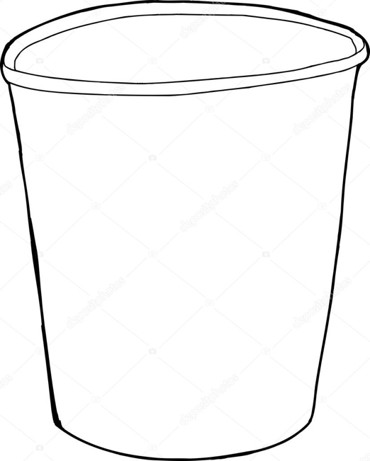 | After pouring all four liquids into the jar, what do you see?

